22.9: a) Since 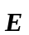 is uniform, the flux through a closed surface must be zero. That is: 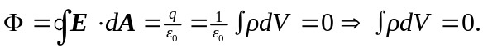 But because we can choose any volume we want, must be zero if the integral equals zero.
b) If there is no charge in a region of space, that does NOT mean that the electric field is uniform. Consider a closed volume close to, but not including, a point charge. The field diverges there, but there is no charge in that region.

